Employer network for refugee inclusion
 | ROUNDTABLE 17 FEB 2021
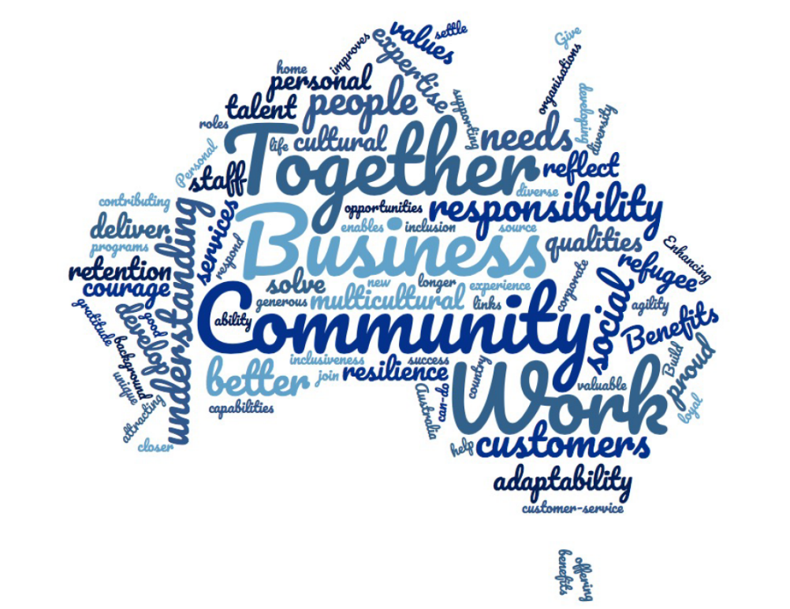 |  |  |  | What is the ENRI?  We’re a group of passionate, committed people from companies that have welcomed refugees as colleagues.  Participants at our February 2021 roundtable were from a range of industries, including retail (IKEA, Koala, Woolworths), transport (Metro Trains), construction and property services (Aurecon, BGIS, LXRP, Sodexo), banking (ANZ), insurance (Allianz), technology (Ericsson, Cisco), management consulting (Accenture) and career coaching (GlowUp Careers), as well as the Department of Justice and Community Safety (Vic). Our network also includes social enterprises that provide opportunities for refugees and asylum seekers to work: The Bread & Butter Project, Green Connect, Outlook, The Social Outfit.  The ENRI is facilitated by  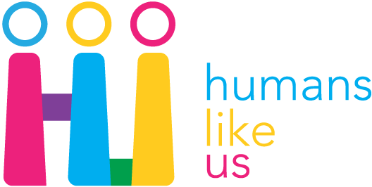Building a bridge for qualified engineers  Many refugees come to Australia as qualified engineers, but face two big barriers to employability in construction: local workplace experience and a local qualification.  Level Crossing Removal Project’s Engineering Pathways Industry Cadetship (EPIC) provides people the opportunity to gain both. An 18-month work-and-study model, cadets are hired as site level engineers and complete a Graduate Certificate with Swinburne University. They go on to fill much-needed infrastructure roles with companies like John Holland and Metro Trains.  Fully utilising people’s skills and experience is a win-win for everyone.
Image: The words employers commonly used when describing why they’ve included refugees in their workforces. Australian Employers’ Guide to Hiring Refugees (Jan 2019).
I want to hire refugees, but how do I reach them?
Community organisations build a bridge
-------------- |  | Once you have your foot in the door, and an opportunity to familiarise yourself with how Australian workplaces function, it makes it that much easier to apply for the next job.  Companies set their new recruits up for success by:  - Adjusting the way candidates are assessed (more tips here)  - Tailoring induction and onboarding (more tips here)  - Matching recruits with a buddy and providing ongoing support.  Many Australian employers have found that retention rates are higher for workers from a refugee experience than overall; this is also reflected in research about employers in the USA.  Many thanks to IKEA, LXRP, Metro Trains & Woolworths for inspiring us all.
Every employer has developed a bespoke solution.

Some partner with one community organisation with expertise in sourcing refugee job candidates, who offers recruitment services tailored to an employer’s needs.

This can include cultural awareness training for your current teams, who may be meeting someone who’s been a refugee for the first time.

For others, maintaining a network of community organisations who help refugee and asylum seeker jobseekers navigate the job market, gives their business-as-usual recruiters a way to promote vacancies to a hard-to-reach talent pool.

Many newcomers find it difficult to break into the job market without Australian work experience, so some employers offer paid work placements, internships or cadetships to act as a bridge into employment.

ENRI Feb 2021
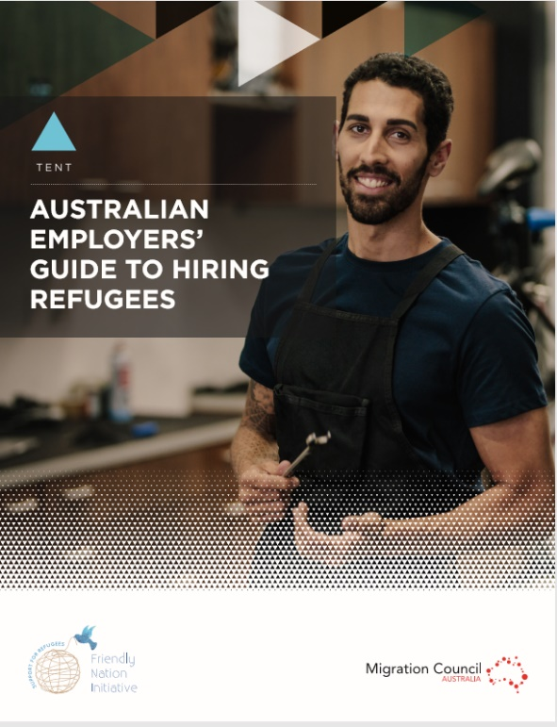 |  |  | Getting started  The Humans Like Us website has everything you need to help you make the business case to your colleagues, find community partners and figure out which approach might suit you best.  These two reports (L) are useful background reading, and check out these multimedia resources:  Refugee employment (USyd)  Practical inclusion: refugee employment (Dr Bree Gorman & Humans Like Us)  Refugee Week  (20-26 June)  To amplify our individual efforts in welcoming refugees as colleagues, the ENRI is planning a Refugee Week event.  One suggestion was to launch a vox pop video featuring stories from refugees about their experiences at work, and building some promotional events around that.  Contact Selena if you’d like to be part of our working group.  Social media engagement  Every roundtable is an opportunity to raise awareness of these issues with your wider network. Together we can share and like each other’s posts, to spread the word about the difference that so many of you are making to people’s lives.
Click on the pictures to check out these resources.
Refugee news
Around the world and in Australia
--------------  The UN reports that the economic impact of the COVID-19 pandemic is having the greatest impact on humanitarian needs. They project 235 million people will need help in 2021, a 40% increase. Detailed report here.  Several conflicts continue to force millions of people to be displaced, including:  - Conflict in Tigray, Ethiopia, has forced 50,000 people into Sudan, and endangered 100,000 Eritrean refugees living in camps in Tigray.  - The 6-year-old war in Yemen has forced it to the brink of famine, with 80% of people relying on aid.  - Political dissidents in Hong Kong are seeking asylum. | - Fighting in Northern Syria forced over 1 million people from their home.  2020 saw the lowest rates of refugee resettlement in almost 20 years, with only 15,425 refugees resettled from Jan-Sep, down from 50,086 (2019), but the US will now resume its annual intake of 125,000 places (cf 15,000).  In Australia:  - 13,171 people were resettled in 2019-20, less than the 18,750 planned. The size of the humanitarian program was reduced in 2020-21 to 13,750 places p.a.  - 61 people were released from Melbourne immigration detention.  - NSW Health will waive fees for people seeking asylum who aren’t eligible for Medicare.
Save the dates: One-hour masterclasses in refugee inclusion
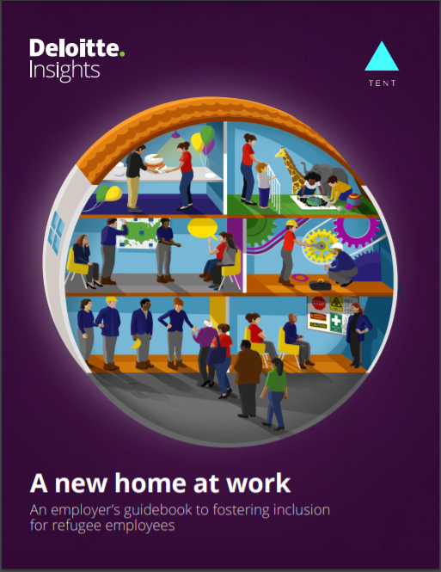 | The purpose of the ENRI is to amplify our efforts and support each other.  We meet as a roundtable by video for one hour every quarter.  This year we’ll be working through different steps of inclusion, drawing lessons from A new home at work:  An employer’s guidebook to fostering inclusion for refugee employees, a report from Deloitte and the Tent Partnership for Refugees based on interviews with over 90 employers, refugee employees and other experts. | Roundtable 2021 focus topics  Thu 6 May  How to conduct an inclusive interview.  Wed 21 July  Meet community organisations supporting refugee job seekers.  Thu 9 September  How to onboard new recruits and prepare host teams to set up for success.  Wed 27 October  Year in review: What companies have done in 2021 to help address the worldwide refugee situation.

