Employer network for refugee inclusion
 | ROUNDTABLE 6 MAY 2021
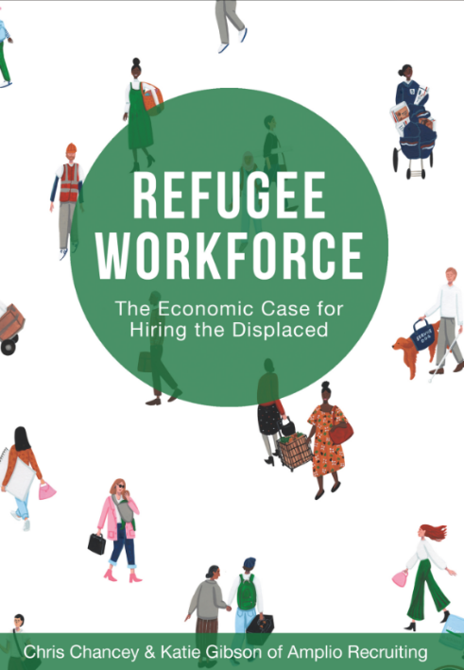 |  |  |  | What is the ENRI?  We’re a group of passionate, committed people from companies that have welcomed refugees as colleagues.  Participants at our May 2021 roundtable were from a range of industries, including retail (Woolworths, IKEA, Koala), construction and property services (Major Road Projects Vic, Suburban Rail Loop Authority Vic, BGIS, Sodexo), law (Maddocks), technology (Cenitex, Philips Healthcare Australia, Ericsson) and career coaching (GlowUp Careers), as well as the Department of Jobs, Precincts and Regions (Vic). Our network also includes social enterprises that provide opportunities for refugees and asylum seekers to work: The Social Outfit, The Bread & Butter Project, Green Connect, Outlook.  The ENRI is facilitated by  That crucial first job  A catch-22 that refugees face, including those who were leaders in their field, is that employers won’t give them a chance because they have no local Australian work experience or referees. Getting work is even harder with no local networks.  IKEA Australia’s Skills for Employment Program is an 8-week paid work placement that provides participants with an introduction to the Australian workplace, skills training, to build English language confidence, and a reference. Critically, “they’re provided with a really authentic co-worker experience.”  Although originally designed as a pathway into any industry, 87% of participants have stayed on to work in other jobs at IKEA.
Click on the pictures to read more about the business case for hiring refugees in Refugee Workforce. Follow Welcome Merchant on Instagram to find refugee-powered businesses.
Inclusive interviews & preparing refugees for day one

-------------- |  | The culture in Australian workplaces can also be very unfamiliar for refugees. Some differences include the level of informality (eg calling managers by their first name), workers being individually responsible for workplace health and safety, and expectations that individuals should show initiative in certain situations.  Many employers provide new recruits with pre-employment training before their first day, to help them familiarise themselves with both physical workplace and the organisation. This might also include, for eg, providing WHS information in Easy Read English and pictorial forms, to facilitate understanding. Employers also commonly providing cultural awareness training to host teams before day one, and pair recruits with a buddy who can provide friendship and ongoing support.  Many thanks to Alice & Harriet (IKEA), Jacqui (Sodexo), Anne (Outlook), Rachel (Woolworths), Yvonne (Glow Up Careers) for sharing your experiences.
For many refugees, finding work in their home countries did not involve a job interview. Given it’s a very common component of Australian recruitment processes, it presents another challenging barrier to refugees securing a job, particularly those from professional backgrounds.

The group shared these ideas to make interviews more inclusive for applicants from a refugee experience:
- make the physical environment welcoming
- help applicants prepare and use an interpreter if that’s helpful
- reframe the “interview” as being an informal conversation to get to know the applicant better, or consider assessing capabilities in other ways
- make the applicant feel more confident by asking them about an achievement.

Read more tips on conducting culturally-sensitive interviews, suggested phrases for culturally-competent interviews and tips on differences in body language to be aware of.

ENRI May 2021
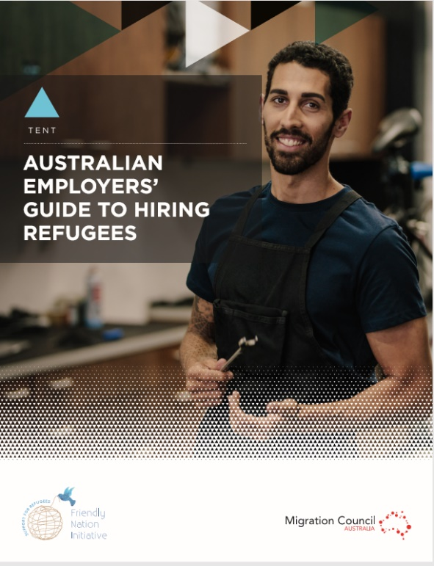 |  |  | Your questions  Q: We need people who can jump in and start straight away. Are refugees able to do this?  A: There are many highly skilled, highly qualified refugees who’ve worked for years. They are mature and experienced workers, who understand the responsibilities of work.  Often what’s unfamiliar isn’t the task at hand, but about how to work and interact with others (eg hierarchy works differently in Australian workplaces). Many companies overcome this by organising a peer to be a new recruit’s trusted buddy.  Companies have found incredible talent in their entry-level recruits from the refugee workforce.  Many thanks to Alice (IKEA), Diane (Ericsson) & Rachael P (Woolworths) for your insights.  Getting started  The Humans Like Us website has everything you need to help you make the business case to your colleagues, find community partners and figure out which approach might suit you best.  These two reports (top left) are useful background reading, and check out these multimedia resources:  Refugee employment (USyd)  Refugee workforce: How companies like ANZ have tapped into a little-known source of diversity (Aventedge Workforce Inclusion & Diversity conference.
Click on the pictures to check out these resources.
Refugee news
Around the world and in Australia
--------------  A new report from UNHCR showing how climate change is driving new displacement in vulnerable populations. Underlying poverty, food insecurity and lack of access to natural resources has been exacerbated by climate change, leading to instability and violence.  Several conflicts continue to force millions of people to be displaced:  - The coup in Myanmar is causing displacement of thousands of people, including ethnic minorities such as the Karen.  - Insurgent attacks and atrocities in Mozambique (including beheadings and rape) has forced over 650,000 people to flee.  - A devastating fire raged through Cox’s Bazaar refugee camp in Bangladesh, killing 15 and destroying shelter and belongings of over 48,000 refugees. | In Australia:  - The government allowed people from Myanmar on temporary visas to apply to extend their visas in the wake of the military coup.  - Refugees who’d been in offshore detention in PNG reported being held at gunpoint and assaulted after an armed gang broke into their accommodation.  Further reading  Refugee employment support: The HRM-CSR nexus and stakeholder co-dependency (by Eun Su Lee and Betina Szkudlarek, Human Resource Management Journal)  ‘Calling In’ Instead of ‘Calling Out’ Behaviour (Lisa Kapinski, Inclusion Nudges)
Upcoming refugee inclusion roundtables
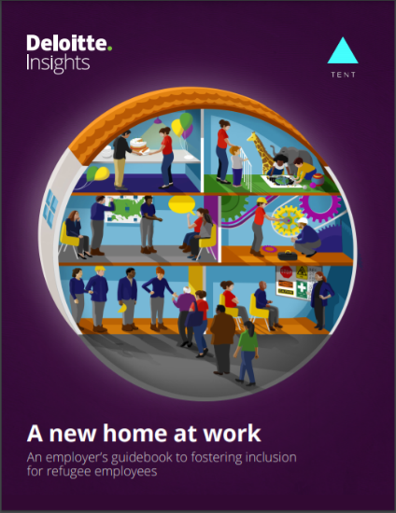 | The purpose of the ENRI is to amplify our efforts and support each other.  We meet as a roundtable by video for one hour every quarter.  This year we’ll be working through different steps of inclusion, drawing lessons from A new home at work:  An employer’s guidebook to fostering inclusion for refugee employees, a report from Deloitte and the Tent Partnership for Refugees based on interviews with over 90 employers, refugee employees and other experts. | Save the dates  Wed 21 July  At the start: Sharing practical lessons  Thu 9 September  How to onboard new recruits and prepare host teams to set up for success.  Wed 27 October  Year in review: What companies have done in 2021 to help address the worldwide refugee situation.

