Employer network for refugee inclusion
 | ROUNDTABLE 21 JULY 2021
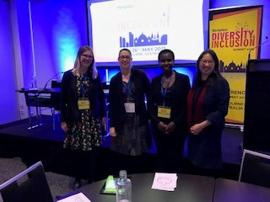 |  |  |  | What is the ENRI?  We’re a group of passionate, committed people from companies that have welcomed refugees as colleagues.  Participants at our July 2021 roundtable were from a range of industries, including banking (ANZ), retail (IKEA), transport (Major Road Projects Vic, Metro Trains), technology (Ericsson), education (TAFE) and career coaching (GlowUp Careers), as well as the Department of Justice and Community Safety (Vic). Our network also includes social enterprises that provide opportunities for refugees and asylum seekers to work: The Bread & Butter Project, Green Connect, Migrant Women in Business, The Social Outfit.  The ENRI is facilitated by  Community refugee sponsorship  Ordinary Canadians have directly welcomed and supported 325,000 refugees into their communities for more than 40 years. This kind of ‘private sponsorship’ is not yet possible in Australia. Our refugee intake is fixed by the government, currently at 13,750 p.a.  Community Refugee Sponsorship Australia is advocating for a change. Part of this involves demonstrating there are communities around Australia willing and able to step up.  You could be involved in group mentorship – where a neighbourhood group is paired with a refugee or family already living here, to provide practical support. A critical contribution is growing people’s networks by sharing yours – also a key component of successful refugee employment programs.
ENRI presentation at Workplace Diversity & Inclusion Conference, Melbourne, May 2021
(L-R) Angela Brown, Level Crossing Removal Project, Louise Ellis & Olivia Kyomugisha (ANZ), Selena Choo, Humans Like Us
Making new connections
-------------- |  | Party-goers came from all walks of life – corporate, community, higher education, recruitment, government. Some were refugee entrepreneurs being promoted by Welcome Merchant; others were refugees looking for work, being coached by Glow Up Careers. One of them, an aspiring financial adviser, met someone from a bank, who offered him a job in the weeks afterwards!  “A great night meeting and hearing from some really inspiring people.”  Our gift bags (from the University of Sydney Business School) were crammed full of goodies from employers of refugees and asylum seekers: ANZ, Woolworths, The Bread and Butter Project and The Social Outfit.  Culture Bites  Rachel Mead spoke about Woolworths’ refugee employment program when she led an online conversation with a group at a Culture Bites Refugee Week event: Great minds don’t think alike – the power of Cognitive Diversity.
A key part of our work is sharing our positive experiences welcoming refugees as colleagues, to raise awareness with new employers and encourage them to think about refugees differently.
Workforce Diversity & Inclusion conference
Louise Ellis and Olivia Kyomugisha from ANZ, together with Angela Brown from LXRP and Selena Choo from Humans Like Us, gave a presentation to diversity & inclusion practitioners called Refugee workforce: How organisations like ANZ and LXRP have tapped into a little-known source of diversity.
Refugee Week cocktail party
What a joyful event this was! Held at Colombo Social Lankan Bar and Kitchen and co-hosted by Humans Like Us and Glow Up Careers, guests enjoyed delicious canapes and heard from speakers about their experiences of looking for work as a refugee in Australia.

ENRI July 2021
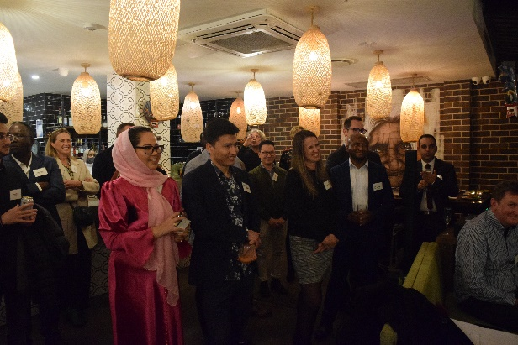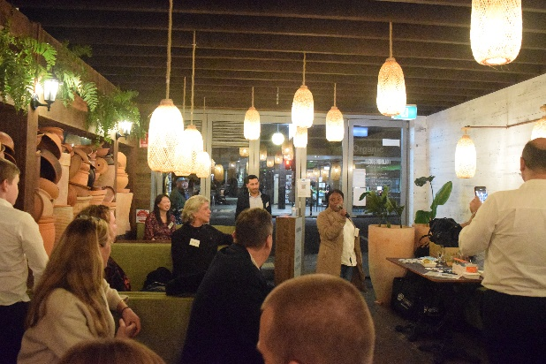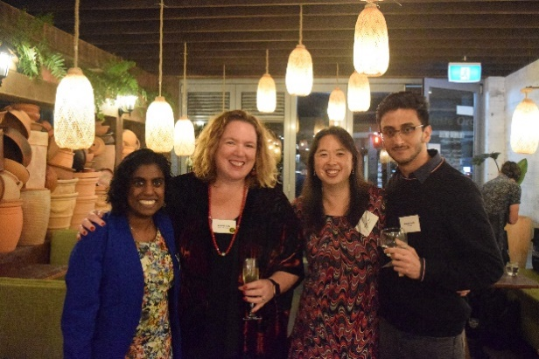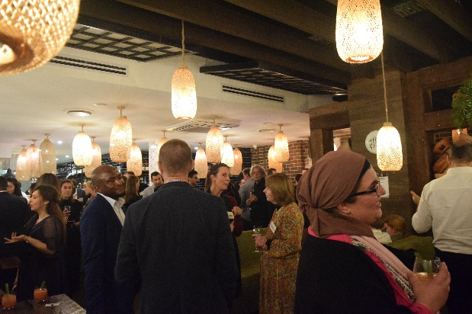 |  |  | Your questions  Q: Is there a way we could ask if someone was a refugee in a job application form, to identify if we could provide them with extra support?  A: It’s a great idea to offer extra support during recruitment! Some companies already ask applicants if they have a disability, for this purpose.  However, we couldn’t think of a way to ask if someone was a refugee without causing confusion, and which would reliably identify people who needed extra support.  Here’s why:  - It would be confusing to use the term “refugee” on a job application form, because the term has different meanings depending on the context (and sometimes has negative connotations).  - To address this confusion, you could adopt the government/charity approach of asking about people’s visa.  - You’d need to make the purpose of the question clear, so applicants feel safe disclosing this information.  - This will not help those refugees whose main barrier is that overseas experience and qualifications are perceived by recruiters to be of no value.  Consider this instead  Think about what extra support you’re offering. If, for example, the idea is to help with language barriers, then maybe include a positive statement that support is available.
Refugee Week cocktail party, Colombo Social, Sydney, June 2021
Refugee news
Around the world and in Australia
--------------  The UNHCR released its annual figures: in 2020, 82.4 million people were forcibly displaced across the world (up from 79.5 in 2019), with 20.7 million refugees. More than 2/3 came from 5 countries: Syria, Venezuela, Afghanistan, South Sudan and Myanmar. Their neighbours - Turkey, Colombia, Pakistan and Uganda - host the most refugees.  The UN has also warned of an imminent humanitarian crisis in the wake of the withdrawal of Western troops from Afghanistan that has already caused 270,000 people to be displaced within the country in 2021, and Pakistan expecting 500,000 refugees to cross the border. | 80 Afghans, who worked with the Australian army, and their families, were evacuated as part of Australia’s withdrawal of troops from Afghanistan.  More than 7,000 people have been granted humanitarian visas by Australia but have not been able to come since March 2020 due to border closures.  Amendments to the Migration Act passed in May which give the government the power to indefinitely detain a refugee whose visa has been cancelled and they would face persecution if sent back to their country of origin. Read more here.
Join us at the next roundtable
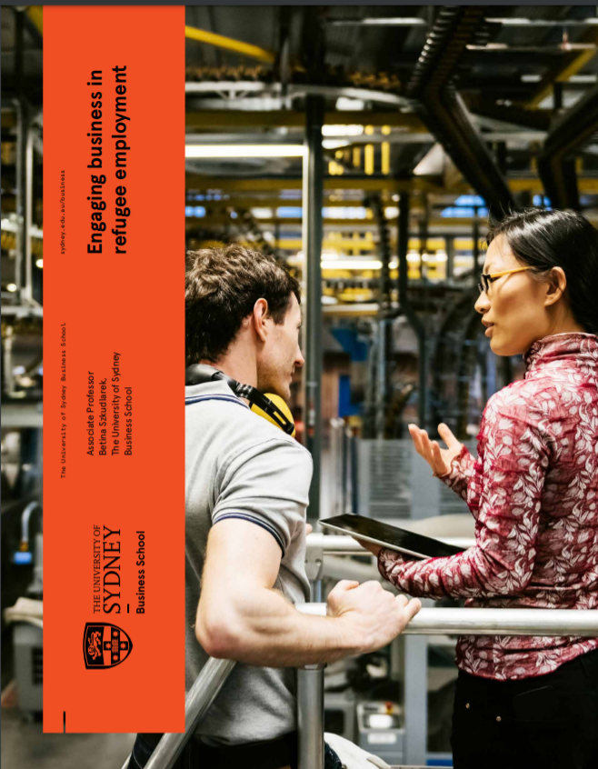 | The purpose of the ENRI is to amplify our efforts and support each other. We meet as a roundtable by video at 1-2pm, every quarter.  Topics at past roundtables include:  - how to talk to managers about the business case for hiring refugees  - how to conduct inclusive interviews.  Save the dates  Thu 9 September  Wed 27 October | Media  Amid a labour shortage, here’s how businesses could hire more refugees – and gain a strategic advantage  (The Conversation)  We can learn from one another: How supporting refugees makes Australia’s business culture better (B&T)  Australia reimagined (Nyadol Nyuon former refugee & lawyer, National Press Club address (30 June 2021)  Podcast interview with Marina Brizar (former refugee, human rights advocate), Helping Displaced Talent

