Employer network for refugee inclusion
 | ROUNDTABLE 9 SEP 2021
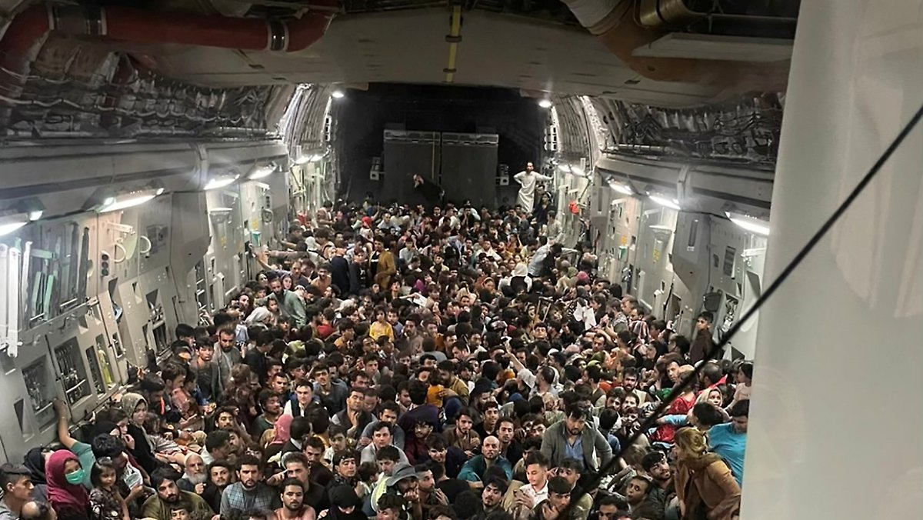 |  |  |  | What is the ENRI?  We’re a group of passionate, committed people from companies that have welcomed refugees as colleagues.  The purpose of the ENRI is to amplify our efforts and support each other.  Participants at our September 2021 roundtable were from a range of industries, including banking (ANZ, Commonwealth Bank), insurance (Allianz), transport (Metro Trains), property services (Sodexo, BGIS), retail (Woolworths, Imperial Brands), technology (Ericsson), law (Hall & Wilcox), energy (Ausnet Services) and career coaching (GlowUp Careers).  Participants also came from State government agencies, including Homes Victoria, the NSW Ombudsman and the Victorian Department of Families, Fairness and Housing.  Our network also includes social enterprises that provide opportunities for refugees and asylum seekers to work: The Social Outfit, Green Connect, The Bread & Butter Project, Migrant Women in Business, Colombo Social.  The ENRI is facilitated by
Evacuation of over 600 Afghans on a US military flight (CA News, Ottawa, 17 August 2021)
Support for affected refugee employees
-------------- |  | The focus for employers was providing staff with psychological support and access to leave to attend to their personal needs and responsibilities. In one company, a senior manager sent a personal email to each staff member affected, offering support and assistance.  Staff members were supported with connections to pro bono legal assistance.  Employers also ensured other staff, who might be impacted psychologically by recent events because of their own refugee experiences, had access to specialist support from community partners.  If your employees need assistance, click here for pro bono legal and counselling services they can access; and here for visa options for people who want to escape Afghanistan.
Over half a million people have been displaced in Afghanistan in 2021. There are currently 2.2 million Afghan refugees in Iran and Pakistan. In August, the Taliban took control of Afghanistan, leading to emergency evacuations of over 120,000 people from Kabul airport. Thousands more tried to flee into neighbouring Pakistan and Iran by road. Read more here.

At our September roundtable, we focused on how Australian employers were responding.

Some employers have staff members who were refugees from Afghanistan, or have family in Afghanistan, and are directly impacted by recent events.

People have been spending day and night organising the logistics of evacuating their families, applying for visas, making efforts to have existing visa applications processed urgently.

ENRI 9 Sep 2021 p 2
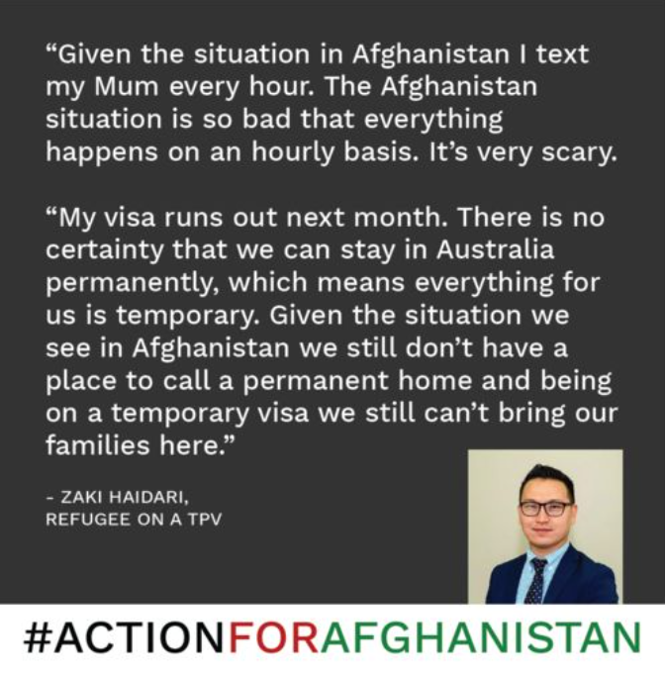 |  |  | Support refugee businesses  Think about refugee-powered businesses when choosing gifts for your friends and colleagues as the end of the year rolls around. Gorgeous self-care and food hampers available from:  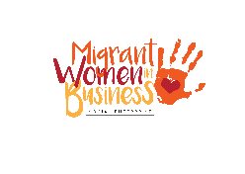  Made by Many Hands  gift catalogue  Goody Bags  Advocate  Action for Afghanistan calls for the government to:  - Increase Australia’s humanitarian intake (currently 13,750 p.a., reduced from the previous annual intake of 18,750), so that more refugees can come from Afghanistan without reducing the number of visas available for refugees from other countries.  - Give permanent protection to the 5,100 people from Afghanistan currently on temporary visas, and amnesty to Afghan nationals currently in Australia.  - Urgently process applications for family visas to bring Afghan families to Australia, which includes prioritising family reunion applications already lodged but currently given low priority.  Watch The Drum (2 min video)  Last roundtable for 2021  Our last roundtable for 2021 is a chance to reflect on the achievements of the group.  Save the date!  Wed 10 November, 12.30-2pm
We thank Zaki Haidari for generously sharing his personal experiences at the September ENRI roundtable and telling us how we can support #ACTIONFORAFGHANISTAN
Other ways employers can respond to the situation in Afghanistan
--------------  Hire refugees  Hundreds of refugees have arrived in Australia since 27 August, including over 500 into NSW, 160 in Perth, arrivals in Brisbane and Melbourne. The fashion industry has pledged to train and employ new migrants.  Donate  A number of organisations are working to help the people of Afghanistan with their food, shelter, healthcare and educational needs.  Talent Beyond Boundaries  Consider hiring for talent through TBB’s innovative employer-sponsored skilled visa pathway for refugees. If you could offer a job to your employee’s friend or family member, TBB might be able to help. Read more here. | Community refugee sponsorship  Form a volunteer group in your local area, or within your organisation, to offer hands-on practical support to a recently-arrived Afghan household or other refugees already in Australia. Read more here.  Help employees on temporary visas  Some staff members affected by the situation in Afghanistan are on temporary protection visas. They face ongoing uncertainty about their future residency and cannot sponsor their families to safety.  Employers could consider seeking legal advice and tapping into the experiences of the ENRI to explore what options they might have to help employees find a permanent home.

