Employer network for refugee inclusion
 | ROUNDTABLE 10 NOV 2021
What is the ENRI?
We’re a group of passionate, committed people from companies that have welcomed refugees as colleagues or are exploring this issue.
Participants at our November 2021 roundtable were from a range of industries, including banking (ANZ, Voltbank), insurance (Allianz), construction (Level Crossing Removal Project), property services (BGIS), retail (Koala, Imperial Brands), technology (Ericsson, Park Agility), law (Maddocks), healthcare (Philips), energy (Energy and Water Ombudsman) and career coaching (GlowUp Careers).
Participants also came from State government agencies, including Multicultural NSW, Inner West Council and the Victorian Department of Families, Fairness and Housing.
Our network also includes social enterprises that provide opportunities for refugees and asylum seekers to work: The Social Outfit, Green Connect, The Bread & Butter Project, Migrant Women in Business, Colombo Social.

The ENRI is facilitated by

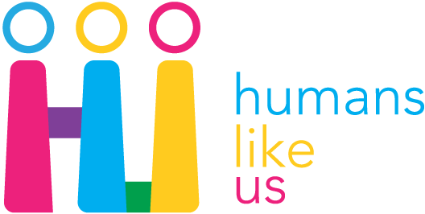

Sharing success stories: word of mouth
-------------- |  | Importance of collaboration  Two new reports share insights into successful ways refugees navigate the Australian job market:  - Humans Like Us, Hidden Talent: Skilled Refugees and Migrants and the Labour Market  - the University of Sydney, Employers Guide to Refugee Employment: a collaborative approach.  Both reports shine a spotlight on the various initiatives and organisations supporting refugees in their working life, emphasising that successful employment outcomes flow from collaboration where each party contributes their expertise.  Many thanks to Louise (ANZ), Yvonne (Glow Up Careers) for sharing your experiences.
At our November roundtable, employers spoke about the importance of word-of-mouth testimonials, raising awareness with colleagues to encourage them to think about refugees differently.

This has been a key force behind the recent growth of ANZ’s refugee and asylum seeker employment program, a 14-year-old partnership with the Brotherhood of St Laurence. The number of participants has more than doubled every year for the past 3 years, with more than 65% moving into permanent roles:
2019 - 8 participants
2020 – 17 participants
2021 – 40 participants.

Most vacancies had been entry-level roles, but in recent years managers have recognised the talent uncovered by the program and different roles have opened up.

ENRI 10 Nov 2021
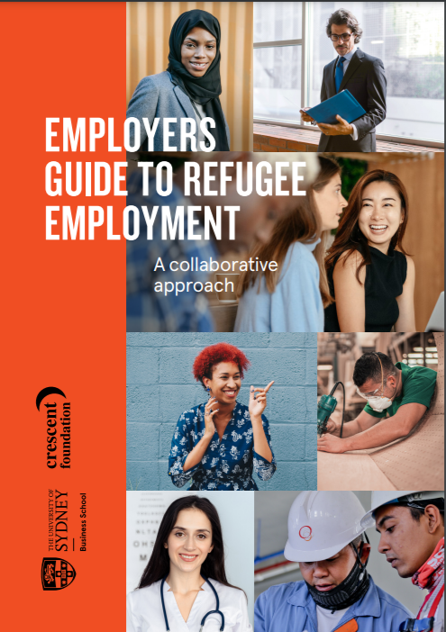 |  |  | Mentoring / coaching refugees & building advocates  Many professional refugees struggle to re-start their career because they don’t know anyone in their field of expertise.  Organisations like Glow Up Careers and the City East Mentor program (Sydney), the Skilled Professional Migrants Program (Melbourne) and the Kaleidoscope Initiative (Perth) connect refugee job seekers with mentors/coaches to guide them through a complicated job market and grow their network.  News about refugee employment programs  Sodexo’s Diversity and Inclusion Commitment taps into refugee talent pool (AMMA)  Podcast interview with Jacqui Bainbridge, Sodexo, about their refugee hiring program  A workforce bridge for refugees, immigrants (Community College Daily, USA)  Channel 9 news story about the Level Crossing Removal Project’s EPIC program  EPIC training program provides pathways for refugee engineers (Engineers Australia create)  Ontario to remove work certification barrier for immigrants (Globe and Mail, Canada)
The Employers Guide to Refugee Employment was released in November.
Breaking news
from December 2021
--------------  On 17 December 2021, the Minister for Immigration, Citizenship, Migrant Services and Multicultural Affairs formally announced enhanced support for refugee settlement and integration.  Significantly, the new measures include:  - $24.6 million in grants to support social enterprises that create new job opportunities and pathways to employment for refugees  - $9.2 million to introduce a new Community Refugee Integration and Settlement Pilot (4 years) in partnership with Community Refugee Sponsorship Australia to | enable community groups to provide an alternative pathway for refugees  - $3.5 million to improve the collection and analysis of data about refugee and humanitarian populations  - reducing the visa application charge for the current Community Support Program to 40% of the current rate for primary applicants and remove it entirely for secondary applicants.  Link to the media release.
Join us for our 2022 roundtables
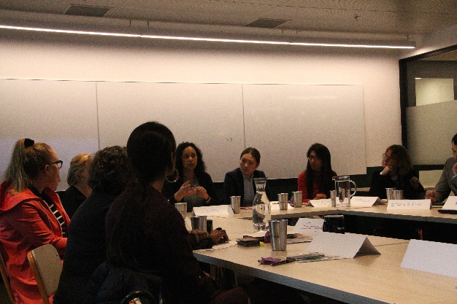 | The purpose of the ENRI is to amplify our efforts and support each other.  We meet every quarter as a roundtable on a Wednesday or Thursday, 12.30-2pm. | Save the dates  Thu 17 February  Thu 12 May  Wed 27 July  Thu 27 October

